**Practical : 1**

**Aim : Create a responsive webpage using Bootstrap.**

**HTML Code :**

<html>

<head>

<title>KScrafts | Home Page</title>

<link rel="stylesheet" href="Style.css">

<link href = "https://fonts.googleapis.com/css2?family=Poppins:wght@200;400;600;800&display=swap" rel = "stylesheet">

<link rel="stylesheet" href="https://cdn.jsdelivr.net/npm/@fortawesome/fontawesome- free@5.15.4/css/fontawesome.min.css">

<link rel="stylesheet" href="https://cdnjs.cloudflare.com/ajax/libs/font-awesome/4.7.0/css/font-awesome.min.css">

</head>

<body>

<div class="header">

<div class="container">

<div class="navbar">

<div class="logo">

<img src="images/logo.png" width="100px" height="80px">

</div>

<nav>

<ul id="MenuItems">

<li><a href="#">Home</a></li>

<li><a href="#">Products</a></li>

<li><a href="#">Blog</a></li>

<li><a href="#">About Us</a></li>

<li><a href="#">Account</a></li>

<li>

<a href="http://localhost/Reg1.php">

Login/Register</a>

</li>

</ul>

</nav>

<img src="images/cart1.png" width="30px">

<img src="images/menu.png" width="30px" class="menu-icon" onclick="menutoggle()">

</div>

<div class="row">

<div class="col-2">

<h1>Let's Go with the<br> Handy knits! </h1>

<p>You can't buy love but you can buy <br>HANDMADE<br>Everyone knows That's nearly the same!<br></p>

<a href="file:///C:/xampp/htdocs/Demo%20Website/Products.html" class="btn">Explore More &#10143;</a>

</div>

<div class="col-2">

<img src="images/Main Page.png">

</div>

</div>

</div>

</div>

<!----------------------------Products Categories--------------------------------

<div class="categories">

<div class="small-container">

<div class="row">

<div class="col-3">

<img src="images/heart-g8a80ffb87_1920.jpg" width="80%" height="282px">

</div>

<div class="col-3">

<img src="images/Puppy baby rattle toy as woodland baby shower gift.jfif" width="80%" height=282px>

</div>

<div class="col-3">

<img src="images/[Free Pattern] Fantastic Crochet Fox Headband For You To Make - Knit And Crochet Daily.jfif" width="80%">

</div>

</div>

</div>

</div>

<!---------------------------- Deals -------------------------------->

<div class="small-container">

<h2 class="title">Today Deals</h2>

<div class="row">

<div class="col-4">

<img src="images/Easy Cozy Crochet Blanket - Dabbles & Babbles.jfif" width="85%">

<h4>Blanket</h4>

<div class="rating">x

<i class="fa fa-star"></i>

<i class="fa fa-star" ></i>

<i class="fa fa-star" ></i>

<i class="fa fa-star-o"></i>

<i class="fa fa-star-o"></i>

</div>

<p>Rs.890/-</p>

</div>

<div class="col-4">

<img src="images/1635350008314.jpg" width="95%">

<h4>Key Chain</h4>

<div class="rating">

<i class="fa fa-star"></i>

<i class="fa fa-star" ></i>

<i class="fa fa-star" ></i>

<i class="fa fa-star" ></i>

<i class="fa fa-star-half-o"></i>

</div>

<p>Rs.250/-</p>

</div>

<div class="col-4">

<img src="images/1635350008305.jpg" width="95%" height="282px">

<h4>Key Chain</h4>

<div class="rating">

<i class="fa fa-star"></i>

<i class="fa fa-star" ></i>

<i class="fa fa-star" ></i>

<i class="fa fa-star" ></i>

<i class="fa fa-star-o" aria-hidden="true"></i>

</div>

<p>Rs.249/-</p>

</div>

<div class="col-4">

<img src="images/ball-g8a383cd09_1920.jpg" width="120%">

<h4>Yarn</h4>

<div class="rating">

<i class="fa fa-star"></i>

<i class="fa fa-star" ></i>

<i class="fa fa-star" ></i>

<i class="fa fa-star-o" ></i>

<i class="fa fa-star-o"></i>

</div>

<p>Rs.200/-</p>

</div>

</div>

<h2 class="title">More Products</h2>

<div class="row">

<div class="col-4">

<img src="images/головные уборы _ Записи в рубрике головные уборы _ Дневник Juliy_Li _ LiveInternet - Российский Сервис Онлайн- Дневников.jfif" width="80%">

<h4>Tedday Cap</h4>

<div class="rating">

<i class="fa fa-star"></i>

<i class="fa fa-star" ></i>

<i class="fa fa-star" ></i>

<i class="fa fa-star" ></i>

<i class="fa fa-star-half-o"></i>

</div>

<p>Rs.499/-</p>

</div>

<div class="col-4">

<img src="images/Como Fazer Roupas de Bebê de Crochê_ Passo a Passos +46 Fotos _ Revista Artesanato.jfif" width="95%">

<h4>Bunny Jacket</h4>

<div class="rating">

<i class="fa fa-star"></i>

<i class="fa fa-star" ></i>

<i class="fa fa-star" ></i>

<i class="fa fa-star" ></i>

<i class="fa fa-star"></i>

</div>

<p>Rs.1099/-</p>

</div>

<div class="col-4">

<img src="images/Criss Cross Beanie - Free Crochet Pattern Loops & Love Crochet.jfif" width="95%">

<h4>Multicolour Cap</h4>

<div class="rating">

<i class="fa fa-star"></i>

<i class="fa fa-star" ></i>

<i class="fa fa-star" ></i>

<i class="fa fa-star" ></i>

<i class="fa fa-star-o" ></i>

</div>

<p>Rs.660/-</p>

</div>

<div class="col-4">

<img src="images/Kmittens.png" width="75%" >

<h4>Gloves</h4>

<div class="rating">

<i class="fa fa-star"></i>

<i class="fa fa-star" ></i>

<i class="fa fa-star" ></i>

<i class="fa fa-star-o" ></i>

<i class="fa fa-star-o"></i>

</div>

<p>Rs.339/-</p>

</div>

</div>

<div class="row">

<div class="col-4">

<img src="images/CROCHET PATTERN PDF Crocheted spiral flower headband _ _ Etsy.jfif" width="95%">

<h4>Hair Band</h4>

<div class="rating">

<i class="fa fa-star"></i>

<i class="fa fa-star" ></i>

<i class="fa fa-star" ></i>

<i class="fa fa-star" ></i>

<i class="fa fa-star-half-o"></i>

</div>

<p>Rs.490/-</p>

</div>

<div class="col-4">

<img src="images/fe92ed72-88e8-4fea-9f40- 34400bed3886.jfif" width="75%">

<h4>Cap</h4>

<div class="rating">

<i class="fa fa-star"></i>

<i class="fa fa-star" ></i>

<i class="fa fa-star" ></i>

<i class="fa fa-star-half-o" ></i>

<i class="fa fa-star-o"></i>

</div>

<p>Rs.750/-</p>

</div>

<div class="col-4">

<img src="images/Panda bear crochet pattern , amigurumi.jfif" width="65%">

<h4>Panda Toy</h4>

<div class="rating">

<i class="fa fa-star"></i>

<i class="fa fa-star" ></i>

<i class="fa fa-star" ></i>

<i class="fa fa-star" ></i>

<i class="fa fa-star"></i>

</div>

<p>Rs.390/-</p>

</div>

<div class="col-4">

<img src="images/teddy-ga4065ca42_1920.jpg" width="120%">

<h4>Brown Teddy</h4>

<div class="rating">

<i class="fa fa-star"></i>

<i class="fa fa-star" ></i>

<i class="fa fa-star-half-o" ></i>

<i class="fa fa-star-o" ></i>

<i class="fa fa-star-o"></i>

</div>

<p>Rs.555/-</p>

</div>

</div>

<div class="row">

<div class="col-4">

<img src="images/toy-g82c70cf43_1920.jpg" width="95%">

<h4>Soft Duck</h4>

<div class="rating">

<i class="fa fa-star"></i>

<i class="fa fa-star" ></i>

<i class="fa fa-star" ></i>

<i class="fa fa-star" ></i>

<i class="fa fa-star-half-o"></i>

</div>

<p>Rs.220/-</p>

</div>

<div class="col-4">

<img src="images/Warm Solid Beige Khaki Knit Ponytail Beanie Hat _ Color_ Tan _ Size_ Os.jfif" width="95%">

<h4>Pony Cap</h4>

<div class="rating">

<i class="fa fa-star"></i>

<i class="fa fa-star" ></i>

<i class="fa fa-star" ></i>

<i class="fa fa-star" ></i>

<i class="fa fa-star-half-o"></i>

</div>

<p>Rs.450/-</p>

</div>

<div class="col-4">

<img src="images/Small Crochet Projects You Can Make in 1 Day or Less!.jfif" width="95%">

<h4>Basic Leaf</h4>

<div class="rating">

<i class="fa fa-star"></i>

<i class="fa fa-star" ></i>

<i class="fa fa-star" ></i>

<i class="fa fa-star" ></i>

<i class="fa fa-star"></i>

</div>

<p>Rs.190/-</p>

</div>

<div class="col-4">

<img src="images/Edward Gorey Gloves by Carrie Martin _ Project _ Knitting _ Gloves & Mittens _ Kollabora.jfif" width="95%">

<h4>Fancy Gloves</h4>

<div class="rating">

<i class="fa fa-star"></i>

<i class="fa fa-star" ></i>

<i class="fa fa-star-o" ></i>

<i class="fa fa-star-o" ></i>

<i class="fa fa-star-o"></i>

</div>

<p>Rs.490/-</p>

</div>

</div>

</div>

<!-----------------------Offers--------------------->

<div class="offer">

<div class="small-container">

<div class="row">

<div class="col-2">

<img src="images/Kmittens.png" class="offer-img">

</div>

<div class="col-2">

<p>HOT offers are Available on KScrafts</p>

<h1>Fancy Yarn Gloves</h1>

<small>here is the description of the product<!-- description of the product--></small>

<a href="" class="btn">Buy Now &#8594;</a> <!--- here amke one page related to product and add link-->

</div>

</div>

</div>

</div>

<!-------------- testimonial ---------------->

<div class="testimonial">

<div class="small-container">

<div class="row">

<div class="col-3">

<i class="fa fa-quote-left"></i>

<p>Lorem ipsum dolor sit amet consectetur adipisicing elit. Itaque, nesciunt. Quidem, dolorum! Culpa, modi!

Laboriosam dignissimos fugit exercitationem</p>

<div class="rating">

<i class="fa fa-star"></i>

<i class="fa fa-star" ></i>

<i class="fa fa-star" ></i>

<i class="fa fa-star" ></i>

<i class="fa fa-star-half-o"></i><!---in place of this using link part --->

</div>

<img src="images/teddy-ga4065ca42_1920.jpg">

<h3>Sean Parker</h3>

</div>

<div class="col-3">

<i class="fa fa-quote-left"></i>

<p>Lorem ipsum dolor sit amet consectetur adipisicing elit. Itaque, nesciunt. Quidem, dolorum! Culpa, modi!

Laboriosam dignissimos fugit exercitationem</p>

<div class="rating">

<i class="fa fa-star"></i>

<i class="fa fa-star" ></i>

<i class="fa fa-star" ></i>

<i class="fa fa-star" ></i>

<i class="fa fa-star-half-o"></i><!---in place of this using link part --->

</div>

<img src="images/teddy-ga4065ca42_1920.jpg">

<h3>Sean Parker</h3>

</div>

<div class="col-3">

<i class="fa fa-quote-left"></i>

<p>Lorem ipsum dolor sit amet consectetur adipisicing elit. Itaque, nesciunt. Quidem, dolorum! Culpa, modi!

Laboriosam dignissimos fugit exercitationem</p>

<div class="rating">

<i class="fa fa-star"></i>

<i class="fa fa-star" ></i>

<i class="fa fa-star" ></i>

<i class="fa fa-star" ></i>

<i class="fa fa-star-half-o"></i><!---in place of this using link part --->

</div>

<img src="images/teddy-ga4065ca42_1920.jpg">

<h3>Sean Parker</h3>

</div>

</div>

</div>

</div>

<!-------------- footer ---------->

<div class="footer">

<div class="container">

<div class="row">

<div class="footer-col-1">

<h3>Download Our App</h3>

<p>Downlaod App for Android and ios mobile phone.</p>

<div class="app-logo">

<img src="images/playstore.jpg">

<img src="images/applestore.png">

</div>

</div>

<div class="footer-col-2">

<img src="images/logo.png" width="50px" height="120px">

<p>Our purpose is to sustainable make the pleasure and benefits of sports accessible to the many.</p>

</div>

<div class="footer-col-3">

<h3>Useful Links</h3>

<ul>

<li>Coupons</li>

<li>Blog Post</li>

<li>Return Policy</li>

<li>Join Affiliate</li>

</ul>

</div>

<div class="footer-col-4">

<h3>Follow us</h3>

<ul>

<li>Facebook</li>

<li>Intagram</li>

<li>Twitter</li>

<li>YouTube</li>

</ul>

</div>

</div>

<hr>

<footer>

<a href=#>FAQ</a>

<a href="#">Contact Us</a>

<a href="#">Terms of Use</a>

<a href="#">Privacy Policy</a>

<a href="#">Refund Policy</a>

<a href="#">&copy; 2020 | KScrafts</a>

</footer>

</div>

</div>

<!----------js for toggle menu -------------->

<script>

var MenuItems = document.getElementById("MenuItems");

MenuItems.style.maxHeight = "0px";

function menutoggle()

{

if(MenuItems.style.maxHeight == "0px")

{

MenuItems.style.maxHeight = "200px";

}

else

{

MenuItems.style.maxHeight = "0px";

}

}

</script>

</body>

</html>

**CSS Code :**

*

{

margin: 0;

padding:0;

box-sizing: border-box;

}

body

{

font-family: 'Poppins', sans-serif;

}

.navbar

{

display: flex;

align-items: center;

padding: 20px;

}

nav

{

flex: 1;

text-align: right;

}

nav ul

{

display: inline-block;

list-style-type:none;

margin-top: 5px;

}

nav ul li

{

display: inline-block;

margin-right: 30px;

}

a

{

text-decoration: none;

color: #555;

}

p

{

color: #555 ;

}

.container

{

max-width: 1300;

margin: auto;

padding-left: 25px;

padding-right:25px ;

}

.row

{

display: flex;

align-items: center;

flex-wrap: wrap;

justify-content: space-around;

}

.col-2

{

flex-basis: 50%;

min-width: 300px;

}

.col-2 img

{

max-width: 100%;

padding: 50px 0;

}

.col-2 h1

{

font-size: 50px;

line-height: 60px;

margin: 25px 0;

}

.btn

{

display: inline-block;

background: rgb(150, 93, 197);

color: #fff;

padding: 8px 30px;

margin: 30px 0;

border-radius: 30px;

transition: background 0.5s;

}

.btn:hover

{

background: rgb(54, 17, 88);

}

.header

{

background: radial-gradient(#fff,rgb(211, 198, 226));

}

.header .row

{

margin-top: 70px;

margin-left: 30px;

}

.categories

{

margin: 70px 0;

}

.col-3

{

flex-basis: 30%;

min-width: 250px;

margin-bottom: 30px

}

.col-3

{

width: 100%;

}

.small-container

{

max-width: 1080px;

margin:auto ;

padding-left: 75px;

padding-right: 25px;

}

.col-4

{

flex-basis: 25%;

padding: 10px;

min-width: 200px;

margin-bottom: 50px;

transition: transform 0.5s ;

}

.col-4

{

width: 100%;

}

.title

{

text-align: center;

margin: 0 auto 80;

position: relative;

line-height: 60px;

color: #555;

}

.title::after

{

content: '';

background: #5a3f86;

width: 80px;

height: 3.5px;

border-radius: 5px;

position: absolute;

bottom: 0;

left: 50%;

transform: translateX(-50%);

}

h4

{

color: #555;

font-weight: normal;

}

.col-4 p

{

font-size: 12px;

}

.rating .fa

{

color: orangered;

}

.col-4:hover

{

transform: translateY(-5px);

}

/*-------------offer---------------*/

.offer

{

background: radial-gradient(#fff,rgb(211, 198, 226));

margin-top: 80px;

padding: 30px 0;

}

.col-2 .offer-img

{

padding: 50px;

}

.testimonial

{

padding-top: 100px;

}

.testimonial .col-3

{

text-align: center;

padding: 40px 20px;

box-shadow: 0 0 20px 0px rgba(0,0,0,0.1);

cursor: pointer;

}

.testimonial .col-3 img

{

width: 50px;

margin-top: 20px;

border-radius: 50%;

}

.testimonial .col-3:hover

{

transform: translateY(-10px);

}

.fa.fa-quote-left

{

font-size: 33px;

color: #5a3f86;

}

.col-3 p

{

font-size: 12px;

margin: 12px 0;

color: #777;

}

.testimonial .col-3 h3

{

font-weight: 600;

color: #555;

font-size: 16px;

}

/* footer */

.footer

{

background: #000;

color: #8a8a8a;

font-size: 14px;

padding: 60px 0 20px;

}

.footer p

{

color: #8a8a8a;

}

.footer h3

{

color: #fff;

margin-bottom: 20px;

}

.footer-col-1, .footer-col-2, .footer-col-3, .footer-col-4

{

min-width: 250px;

margin-bottom: 20px;

}

.footer-col-1

{

flex-basis: 30%;

}

.footer-col-2

{

flex: 1;

text-align: center;

}

.footer-col-2 img

{

width: 180px;

margin-bottom: 20px;

}

.footer-col-3, .footer-col-4

{

flex-basis: 12%;

text-align: center;

}

ul

{

list-style-type: none;

}

.app-logo

{

margin-top: 20px;

}

.app-logo img

{

width: 140px;

}

footer

{

background-color: #333;

overflow: hidden;

}

footer a

{

color: white;

text-align: center;

padding: 10px;

float: left;

}

.menu-icon

{

width: 28px;

margin-left: 20px ;

display: none;

}

/*---------- media query for menu icon----------*/

@media only screen and (max-width:800px)

{

nav ul

{

position: absolute;

top: 70px;

left: 0;

background: #333;

width: 100%;

overflow: hidden;

transition: max-height 0.5s;

}

nav ul li

{

display: block;

margin-right: 50px;

margin-top: 10px;

margin-bottom: 10px;

}

nav ul li a

{

color: #fff;

}

.menu-icon

{

display: block;

cursor: pointer;

}

}

.row-2

{

justify-content: space-between;

margin: 100px auto 50px;

}

select

{

border: 1px solid #9c80bb;

padding:5px ;

}

select:focus

{

outline: none;

}

.page-btn

{

margin: 0 auto 80px;

}

.page-btn span

{

display: inline-block;

border: 1px solid rgb(106, 85, 182);

margin-left: 10px;

width: 40px;

height: 40px;

text-align: center;

line-height: 40px;

cursor: pointer;

}

.page-btn span:hover

{

background-color: rgb(181, 151, 201);

color: white;

}

/*---media query for less than 600 screen size---*/

@media only screen and (max-width: 800px)

{

.row

{

text-align: center;

}

.col-2, .col-3, .col-4

{

flex-basis: 100%;

}

}

**Output :**

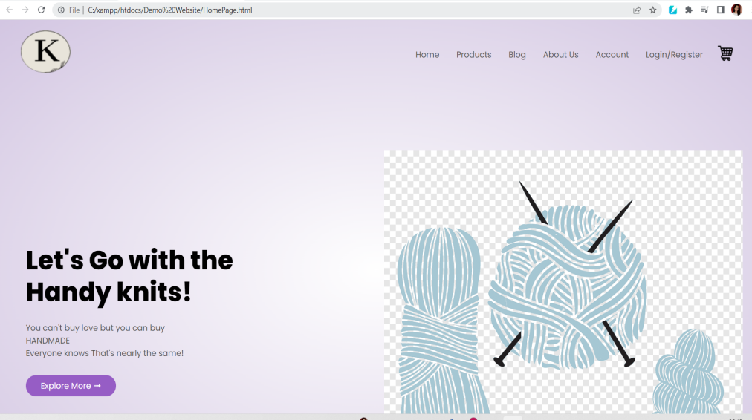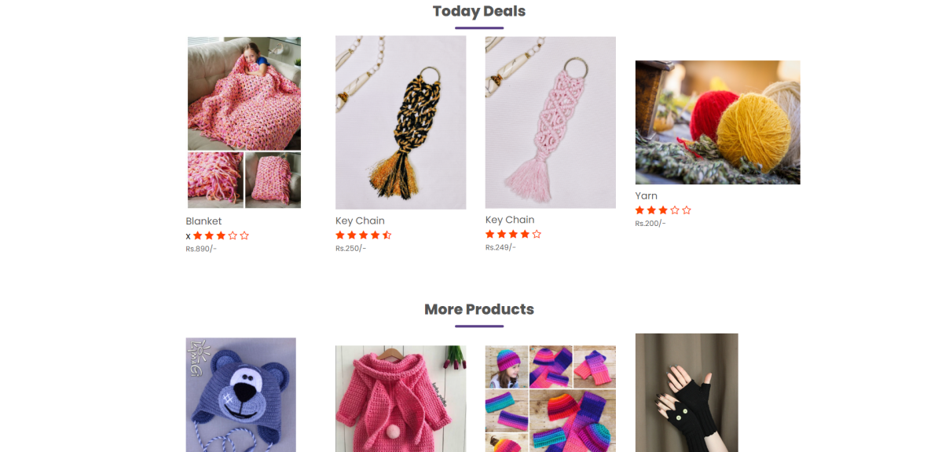

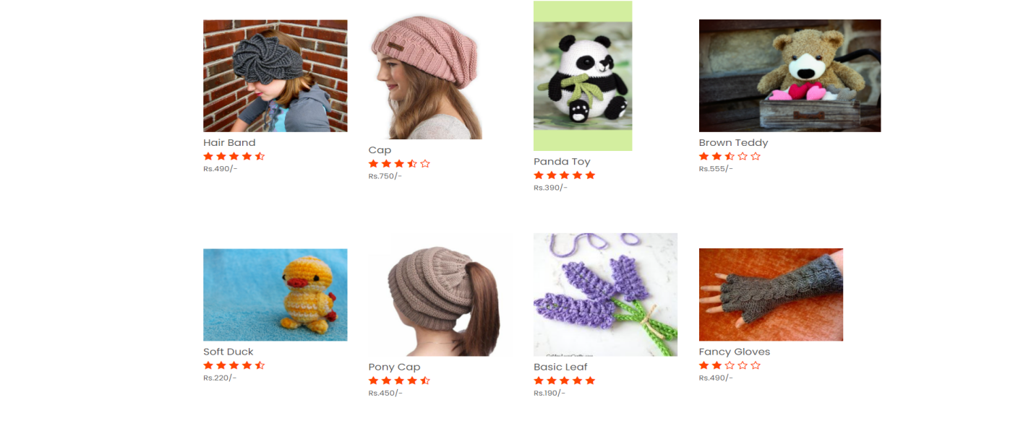

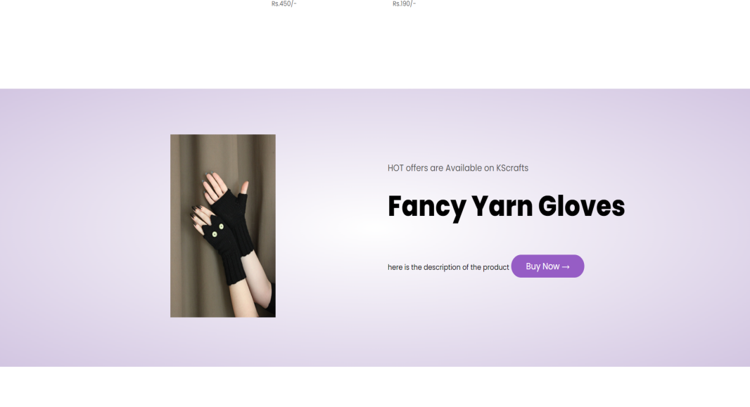

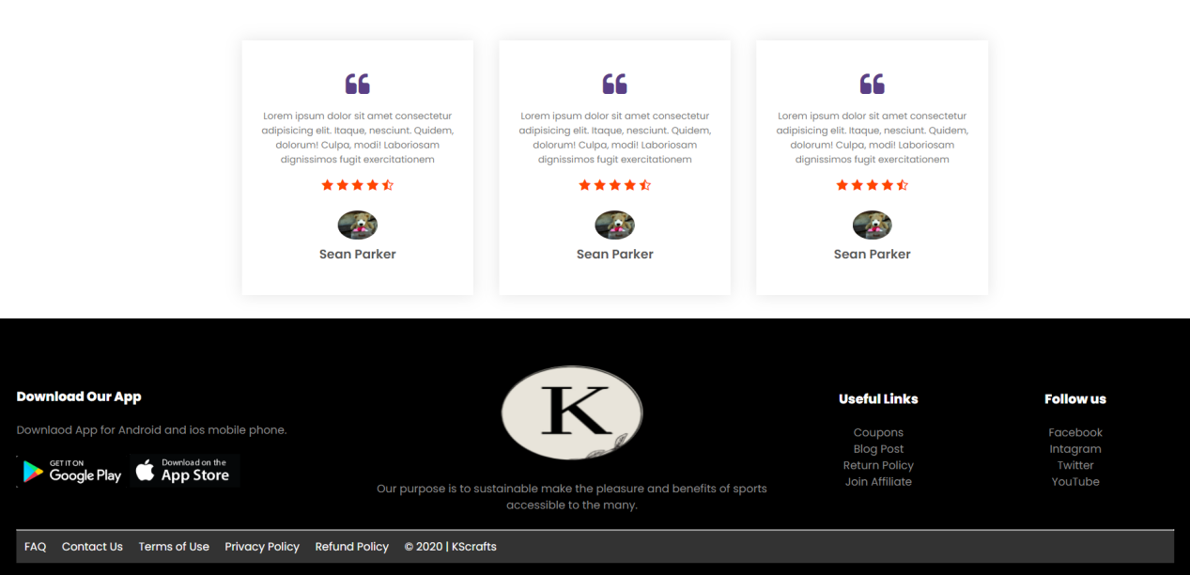

**Practical : 2**

**Aim : Create a calculator using $scope & controllers in AngularJs.**

**Code :**

<!DOCTYPE html>

<html lang="en" ng-app="calculatorApp">

<head>

<meta charset="UTF-8">

<meta http-equiv="X-UA-Compatible" content="IE=edge">

<meta name="viewport" content="width=device-width, initial- scale=1.0">

<title>Calculation</title>

<script src="https://ajax.googleapis.com/ajax/libs/angularjs/1.8.2/angular.min.js">

</script>

</head>

<style>

#background

{

background-size: 30%;

background-repeat: no-repeat;

background-color: #7e737b;

background-position: center;

background-attachment: relative;

}

.container

{

width: 50px auto;

margin:200px 5px 100px 15px;

text-align: center;

padding-bottom: 100px;

position: center;

}

.button

{

position: center;

background-color: white;

width: 80px;

height: 50px;

border: none;

background:none;

top: 20;

bottom: -200;

font-size: 25px;

text-align: center;

margin: 1px;

margin-left: -5px;

margin-right: 20px;

margin-top: 5px;

margin-bottom: -20px;

font-family: varela Round;

color:white;

text-decoration: none;

border-color:white;

}

.button:active

{

background-color: #938a82;

transform: translateY(4px);

opacity:0.1;

border: none;

}

.display input

{

height: 220px;

width: 382px;

text-align: right;

font-size: 50px;

margin-top: 20px;

margin-bottom: -20px;

margin-left: -10px;

opacity: 0.5;

top: 650px;

background: none;

border: 11px solid black;

}

</style>

<body id="background">

<div ng-controller="calculator">

<div class="container">

<div class="display">

<input type="text" value="{{display}}" size="36" id="display" >

</div>

<div class="keys">

<p>

<input type="button" class="button" value="mrc" ng-click="c('not defined')">

<input type="button" class="button" value="+/-" ng-click="math('+/-')">

<input type="button" class="button" value="%" ng-click="math('%')">

<input type="button" class="button" value="/" ng-click="math('&divide')">

</p>

<p>

<input type="button" class="button" value="7" ng-click="math('7')">

<input type="button" class="button" value="8" ng-click="math('8')">

<input type="button" class="button" value="9" ng-click="math('9')">

<input type="button" class="button" value="*" ng-click="math('x')">

</p>

<p>

<input type="button" class="button" value="4" ng-click="math('4')">

<input type="button" class="button" value="5" ng-click="math('5')">

<input type="button" class="button" value="6" ng-click="math('6')">

<input type="button" class="button" value="-" ng-click="math('-')">

</p>

<p>

<input type="button" class="button" value="1" ng-click="math('1')">

<input type="button" class="button" value="2" ng-click="math('2')">

<input type="button" class="button" value="3" ng-click="math('3')">

<input type="button" class="button" value="+" ng-click="math('+')">

</p>

<p>

<input type="button" class="button" value="0" ng-click="math('0')">

<input type="button" class="button" value="." ng-click="math('.')">

<input type="button" class="button" value="c" ng-click="c('')">

<input type="button" class="button" value="=" ng-click="e()">

</p>

</div>

</div>

</div>

<script>

var app = angular.module("calculatorApp", [])

app.controller("calculator",function($scope)

{

$scope.display = "";

$scope.math = function(val)

{

$scope.display += val;

};

$scope.c = function(val)

{

$scope.display = val;

};

$scope.e = function()

{

$scope.display= eval($scope.display);

};

});

</script>

</body>

</html>

**Output :**

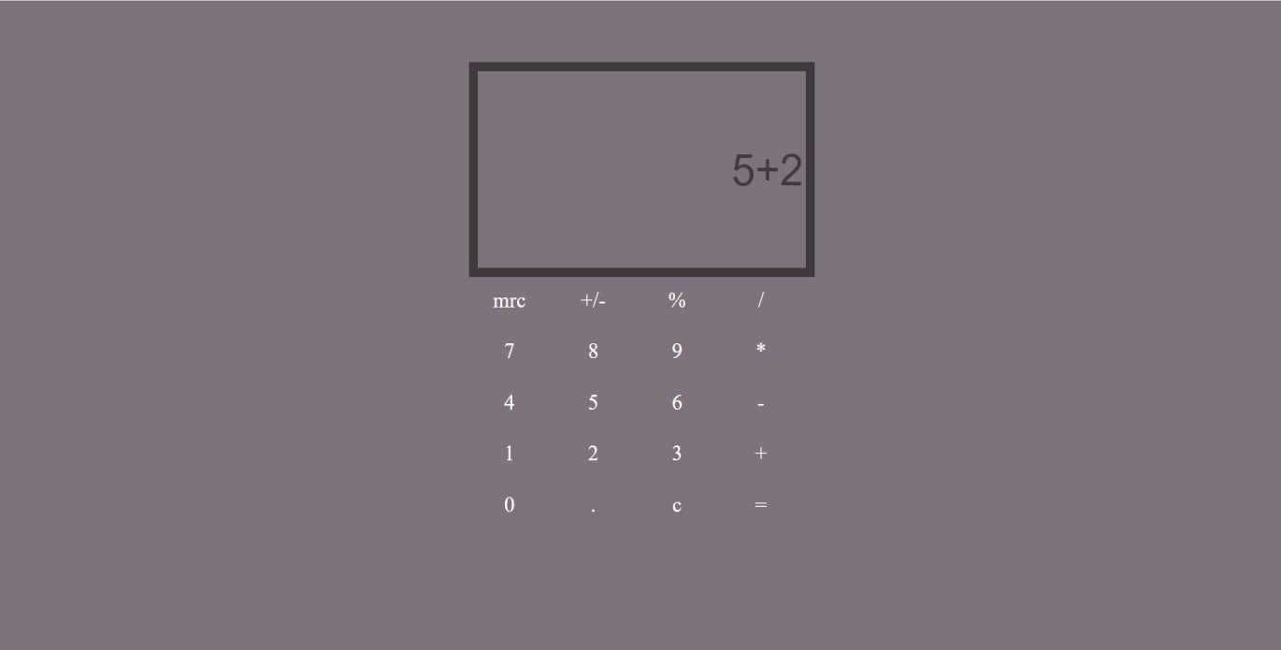 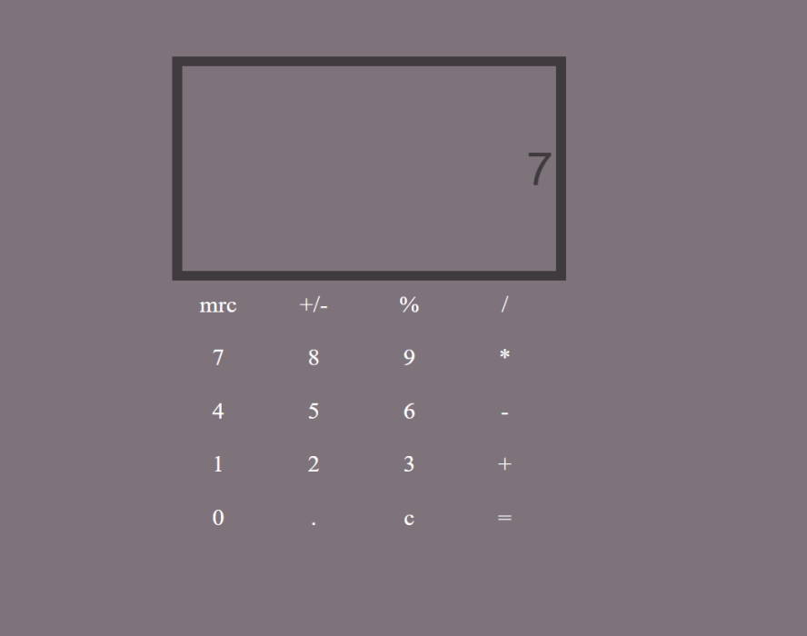

**Practical : 3**

**Aim : Create a webpage to change the theme on button pressed in AngularJs.**

**Code :**

<!doctype html>

<html>

<head>

<script src="https://ajax.googleapis.com/ajax/libs/angularjs/1.8.2/angular.min.js">

</script>

</head>

<body>

<div ng-app='app1' ng-controller='control1'>

<table height=500px width=250px align={{align}} style="background-image:{{color}} ; font-family:{{f}} ;">

<tr>

<th>ANGULAR JS</th>

</tr>

<tr>

<td>AngularJS was a JavaScript-based open-source front-end web framework for developing single-page applications. It was maintained mainly by Google and a community of individuals and corporations.

A JavaScript engine is a software component that executes JavaScript code. The first JavaScript engines were mere interpreters, but all relevant modern engines use just-in-time compilation for improved performance.The use of JavaScript engines is not limited to browsers.

</td>

</tr>

<tr><td>

<input type="button" value="theme 1" ng-click=theme1(); >

<input type="button" value="theme 2" ng-click=theme2();>

<input type="button" value="theme 3" ng-click=theme3();>

</td>

</tr>

</table>

</div>

<script>

x=angular.module("app1",[]);

x.controller("control1",function($scope)

{

$scope.theme1= function()

{

$scope.color = "linear-gradient(red, yellow)"; $scope.align="right";

};

$scope.theme2= function()

{

$scope.color ="linear-gradient(purple, pink)"; $scope.decor="overline";

$scope.align="center";

};

$scope.theme3= function()

{

$scope.color = "linear-gradient(cyan, blue)";

$scope.decor="line-through";

$scope.align="left";

$scope.f="Times";

};

});

</script>

</body>

</html>

**Output :**

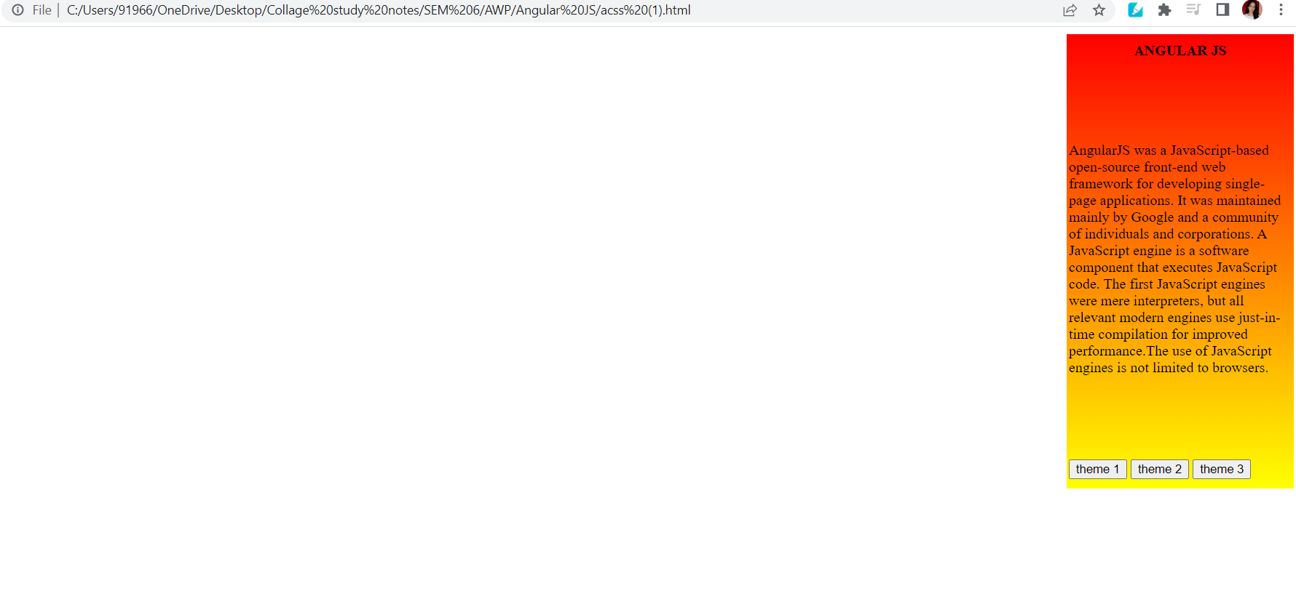

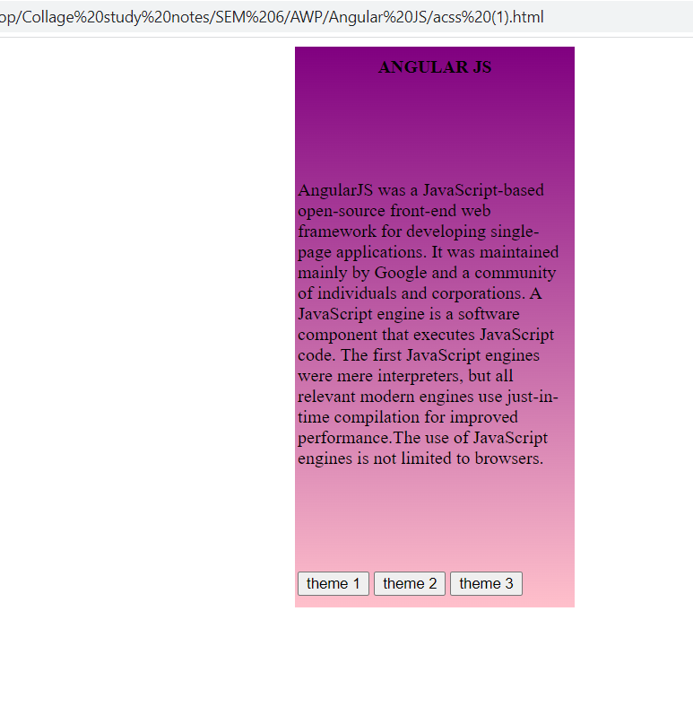

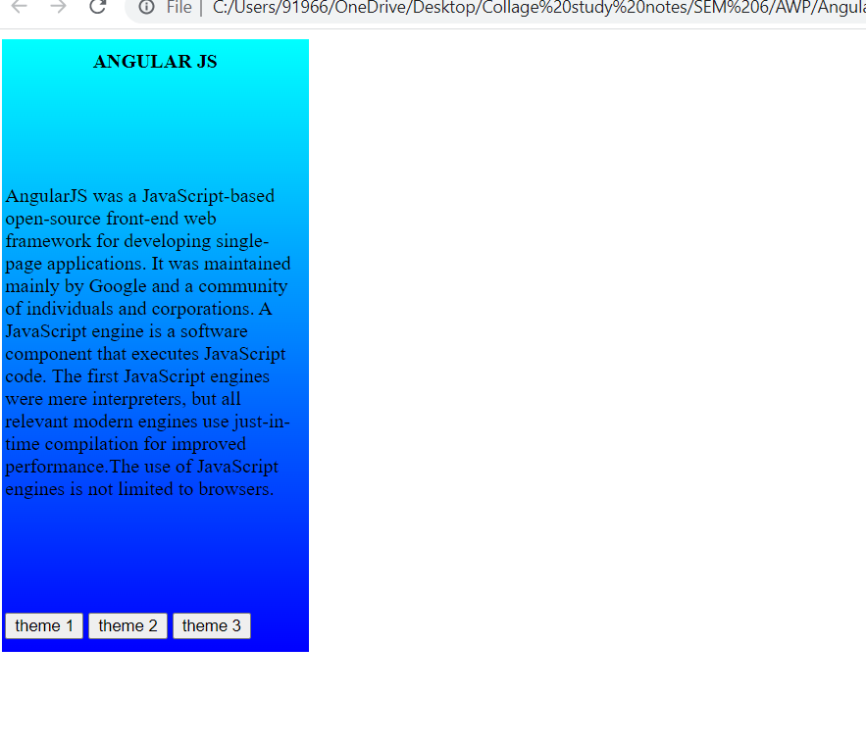

**Practical : 4**

**Aim : Create a Shoppingcart and functions to add and remove items from a Cart using AngularJs.**

**Code :**

**Index.html -**

<!DOCTYPE html>

<html lang = "en">

<head>

<!--angular.js link is download from the original website of the angularJS-->

<script src = "js/angular.js"></script>

<script src = "js/app.js"></script>

<meta charset = "UTF-8" name = "viewport" content = "width=device-width, initial-scale=1" />

<link rel = "stylesheet" type = "text/css" href = "css/bootstrap.css"/>

<link rel = "stylesheet" type = "text/css" href = "css/style.css"/>

<script src= "https://ajax.googleapis.com/ajax/libs/angularjs/1.8.2/angular.min.js"> </script>

<link href="https://cdn.jsdelivr.net/npm/bootstrap@5.1.3/dist/css/bootstrap.min.css" rel="stylesheet" integrity="sha384-1BmE4kWBq78iYhFldvKuhfTAU6auU8tT94WrHftjDbrCEXSU1oBoqyl2QvZ6jIW3" crossorigin="anonymous">

<script src= "https://cdn.jsdelivr.net/npm/bootstrap@5.1.3/dist/js/bootstrap.bundle.min.js" integrity="sha384-ka7Sk0Gln4gmtz2MlQnikT1wXgYsOg+OMhuP+IlRH9sENBO0LRn5q+8nbTov4+1p" crossorigin="anonymous">

</script>

</head>

<body ng-app = "myModule" ng-controller = "myController">

<nav class = "navbar navbar-default">

<div class = "container-fluid">

<a class = "navbar-brand" href = "https://Shoeshop.com">Shoeshop</a>

</div>

</nav>

<div class = "col-md-2"></div>

<div class = "col-md-8 well">

<h3 class = "text-primary">Simple Shopping Cart Application Using AngularJs</h3>

<hr style = "border-top:1px dotted #ccc;"/>

<div id = "bg-background" class = "col-md-7">

<h4>PRODUCTS<h4>

<hr style = "border-top:1px groovy #ccc;">

<div id = "product">

<div id = "p_list" ng-repeat = "product in products ">

<h5>{{product.p_name}}</h5>

<center>

<img ng-src = "{{product.p_image}}"/>

</center>

<div>

<label>Price: Rs.{{product.p_price}}</label>

</div>

<center>

<button type = "button" ng-click = "add_cart(product)">

<span class = "glyphicon glyphicon-shopping-cart"></span>

Add to cart</button>

</center>

</div>

</div>

</div>

<div class = "pull-right col-md-5">

<div class = "panel panel-primary">

<div class = "panel-heading">

<h5>MY CART</h5>

</div>

<div class = "panel-body table-responsive">

<table class = "table">

<thead>

<tr>

<th>Product</th>

<th>Price</th>

<th></th>

</tr>

</thead>

<tbody>

<tr ng-repeat = "cart in carts" ng-init = "setTotals(cart)">

<td>{{cart.p_name}}</td>

<td>Rs.{{cart.p_price}}</td>

<td><button type = "button" ng-click = "remove_cart(cart)" class = "btn btn-danger">

<span class = "glyphicon glyphicon-remove"></span>

</button>

</td>

</tr>

<tr>

<td align = "right">Total</td>

<td>Rs.{{total}}</td>

</tr>

</tbody>

</table>

</div>

</div>

</div>

</div>

</body>

</html>

**Style.css :**

#bg-background{

background-color:#fff;

padding:10px;

border-radius:5px;

}

#product{

padding:5px;

clear:both;

}

#p_list{

width:200px;

max-width:200px;

height:250px;

max-height:250px;

padding:5px;

border:1px solid #000;

float:left;

margin:15px;

}

#p_list img{

height:150px;

width:150px;

}

**app.js :**

var app = angular.module("myModule", [])

app.controller("myController", function($scope){

$scope.carts=[];

$scope.products =

[

{p_id: "1", p_name: "Red platt shoe", p_image: "images/product1.jpg", p_price: 2899},

{p_id: "2", p_name: "comfy fett", p_image: "images/product2.jpg", p_price: 6138},

{p_id: "3", p_name: "Nova", p_image: "images/product3.jpg", p_price: 11000},

{p_id: "4", p_name: “ville shoe", p_image: "images/product4.jpg", p_price: 7517},

{p_id: "5", p_name: "Forza footwear", p_image: "images/product5.jpg", p_price: 5100},

{p_id: "6", p_name: "nike jordan", p_image: "images/product6.jpg", p_price: 9013}

];

$scope.add_cart = function(product){

if(product)

{

$scope.carts.push({p_id: product.p_id, p_name: product.p_name, p_price: product.p_price});

}

}

$scope.total = 0;

$scope.setTotals = function(cart){

if(cart)

{

$scope.total += cart.p_price;

}

}

$scope.remove_cart = function(cart)

{

if(cart)

{

$scope.carts.splice($scope.carts.indexOf(cart), 1);

$scope.total -= cart.p_price;

}

}

});

**Output :**

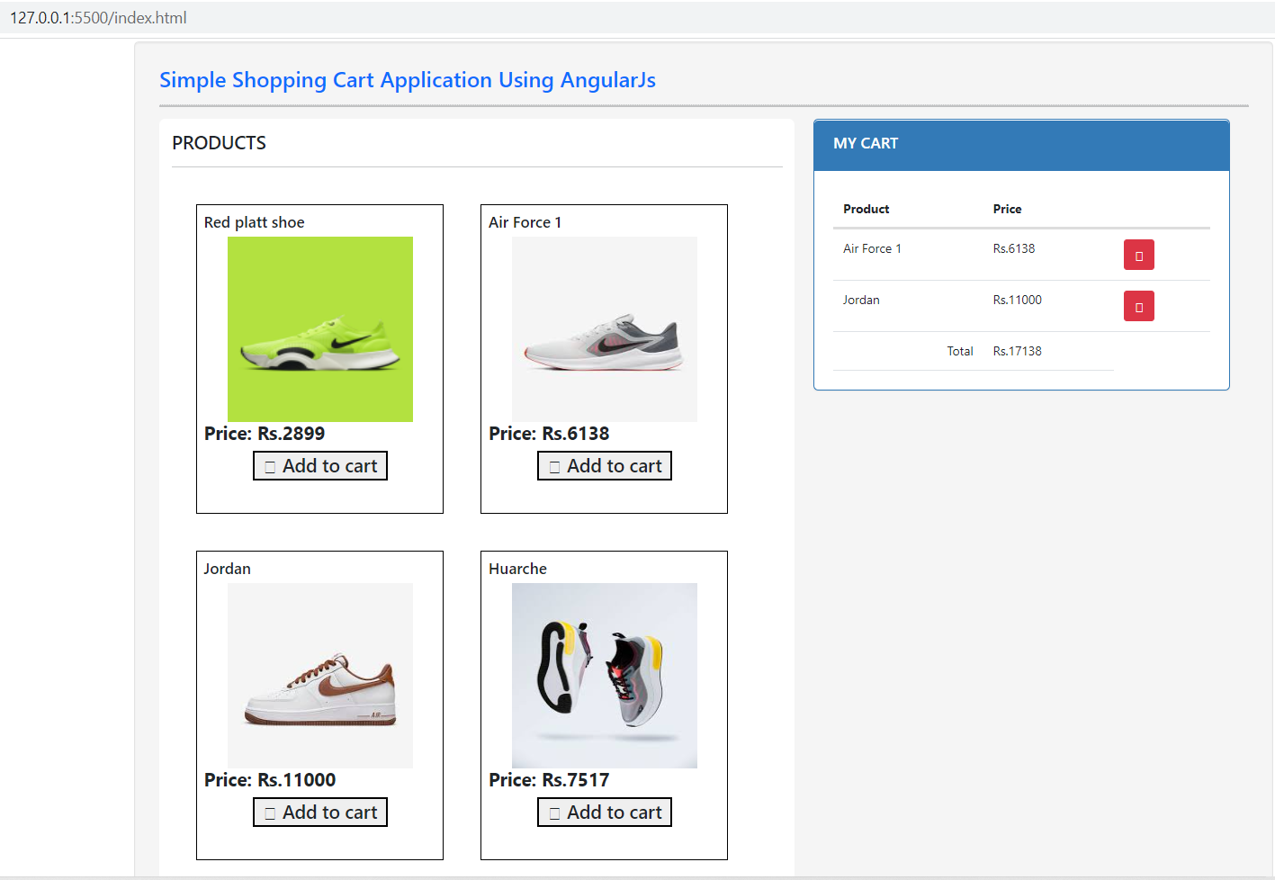

**Practical : 5**

**Aim : Create a Registration form with necessary validations using AngularJs.**

**Code :**

<html>

<head>

<script src="http://ajax.googleapis.com/ajax/libs/angularjs/1.4.9/angular.min.js">

</script>

<link data-require="bootstrap@*" data-semver="3.3.1" rel="stylesheet" href="//maxcdn.bootstrapcdn.com/bootstrap/3.3.1/css/bootstrap.min.css" />

<script data-require="jquery@*" data-semver="2.1.3" src="https://code.jquery.com/jquery-2.1.3.min.js">

</script>

<script data-require="bootstrap@*" data-semver="3.3.1" src="//maxcdn.bootstrapcdn.com/bootstrap/3.3.1/js/bootstrap.min.js">

</script>

<link rel="stylesheet" href="https://cdnjs.cloudflare.com/ajax/libs/font- awesome/4.7.0/css/font-awesome.min.css">

</head>

<style>

.cen

{

padding-left: 500px;

}

.error

{

padding-left: 35px;

color: red;

}

</style>

<body>

<div ng-app="Formvalidation" ng-controller="ctrl" class="cen">

<div class="col-md-5">

<form name="myForm" novalidate="">

<h1>AngularJS Validation</h1>

<label>Full Name</label>

<input type="text" name="name" ng-model="name" pattern="[a-zA-Z ]{1,}" required=""><br>

<span ng-show="myForm.$submitted || myForm.name.$dirty">

<span class="error" ng-show="myForm.name.$error.required">

<i class="fa fa-exclamation-circle" aria-hidden="true">

</i>Name Required

</span>

<span class="error" ng-show="myForm.name.$error.pattern">

<i class="fa fa-exclamation-circle" aria-hidden="true"></i>

Name cannot be Number and special character</span>

</span><br><br>

<label>Gender</label><br>

<input type="radio" name="gender" ng-model="gender" ng- value="&quot;Male&quot;" required="">

<label>Male</label>

<input type="radio" name="gender" ng-model="gender" ng- value="&quot;Female&quot;">

<label>Female</label>

<span ng-show="myForm.$submitted || myForm.gender.$dirty">

<span class="error" ng-show="myForm.gender.$error.required">

<i class="fa fa-exclamation-circle" aria-hidden="true"></i>

Gender Required</span>

</span><br><br>

<label>Date of Birth</label>

<input type="date" name="date" ng-model="date" required=""><br>

<span ng-show="myForm.$submitted || myForm.date.$dirty">

<span class="error" ng-show="myForm.date.$error.required">

<i class="fa fa-exclamation-circle" aria-hidden="true">

</i>

</i> Date of Birth Required</span>

</span><br><br>

<label>Address</label>

<textarea name="address" ng-model="address" required=""></textarea><br>

<span ng-show="myForm.$submitted || myForm.address.$dirty">

<span class="error" ng-show="myForm.address.$error.required">

<i class="fa fa-exclamation-circle" aria-hidden="true"></i>

Address Required</span>

</span><br><br>

<label>Phone Number</label>

<input type="number" name="phone" ng-model="phone" ng- minlength="10" ng-maxlength="10" pattern="/^[7-9][0-9]{9}$/" required=""><br>

<span ng-show="myForm.$submitted || myForm.phone.$dirty">

<span class="error" ng-show="myForm.phone.$error.required">

<i class="fa fa-exclamation-circle" aria-hidden="true"></i>

Phone Number Required

</span>

<span class="error" ng-show="((myForm.phone.$error.minlength || myForm.phone.$error.maxlength) &amp;&amp; myForm.phone.$dirty)">

<i class="fa fa-exclamation-circle" aria-hidden="true"></i> Phone Number Should be 10 digits</span>

</span><br><br>

<label>Course</label>

<select name="course" ng-model="course" required="">

<option>BCom</option>

<option>BA</option>

<option>BCA</option>

<option>BSC</option>

</select>

<br>

<span ng-show="myForm.$submitted || myForm.course.$dirty">

<span class="error" ng-show="myForm.course.$error.required">

<i class="fa fa-exclamation-circle" aria-hidden="true"></i>

Course Required</span>

</span>

<br>

<br>

<label>Email</label>

<input type="email" name="mail" ng-model="mail"

pattern="[a-z0-9]+@[a-z]+\.[a-z]{2,3}" required=""><br>

<span ng-show="myForm.mail.$submitted || myForm.mail.$dirty">

<span class="error" ng-show="myForm.mail.$error.required">

<i class="fa fa-exclamation-circle" aria-hidden="true"></i>

Email Required</span>

<span class="error" ng-show="myForm.mail.$error.pattern">

<i class="fa fa-exclamation-circle" aria-hidden="true"></i>

Invalid Email</span>

</span>

<br>

<br>

<label>Password</label>

<input type="password" name="pass" ng-model="pass"

pattern="[[a-zA-Z0-9][!@#$%^&*()_+{}|:>]]" required="">

<br>

<span ng-show="myForm.pass.$submitted || myForm.pass.$dirty">

<span class="error" ng-show="myForm.pass.$error.required">

<i class="fa fa-exclamation-circle" aria-hidden="true"></i>

Password Required

</span>

<span class="error" ng-show="myForm.pass.$error.pattern"

ng-disabled="myForm.pass.$valid">

<i class="fa fa-exclamation-circle" aria-hidden="true"></i>password should be of 1 Capital letter,special letter,number</span>

</span>

<br>

<br>

<input type="button" value="Submit" name="submit" ng-model="submit" ng-disabled="myForm.$invalid" align="center">

<input type="reset" value="Reset" name="reset" ng-model="reset" align="center">

<br>

</form></div>

</div>

<script>

var pwdModule = angular.module('Formvalidation', []);

pwdModule.controller('ctrl',function($scope)

{

$scope.user = {};

$scope.showmsg = false;

}

);

</script>

</body>

</html>

**Output :**

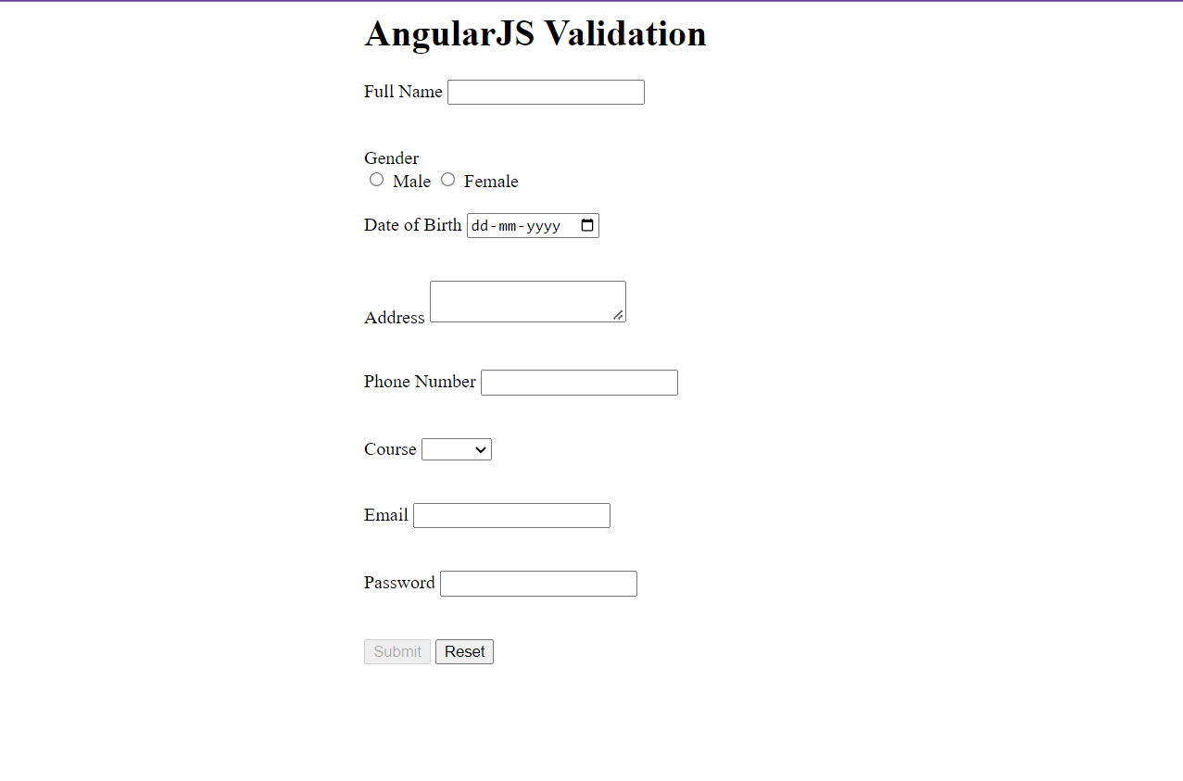

**Practical : 6**

**Aim : Write a program to create a text file ,update it and read that file and print it using fileSystem module in NodeJs.**

**Code :**

const get = require('fs');

get.open("file_1.txt", "w", function (err)

{

if (err) throw err;

   console.log("file created");

});

get.appendFile("file_3.txt", "wd", function (err)

{

if (err) throw err;

  console.log("done");

});

get.readFile("file_1.txt", "utf8", function (err, data)

{

if (err) throw err;

  console.log("done");

  console.log(data);

});

**Output :**

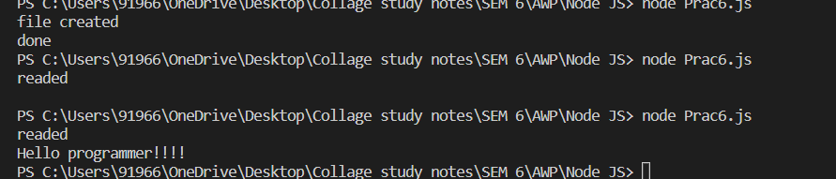

**Practical : 7**

**Aim : Create a server and load your website on that server using NodeJS.**

**Code :**

const hp = require("http");

const f = require("fs");

const val = hp.createServer((req,res)=>

{

f.readFile("calc.html","utf8",function(err,data)

{

if (err) throw err;

res.write(data);

res.end();

});

});

val.listen(3000,(err)=>

{

if (err) throw err =>

console.log("Started");

});

**Output :**

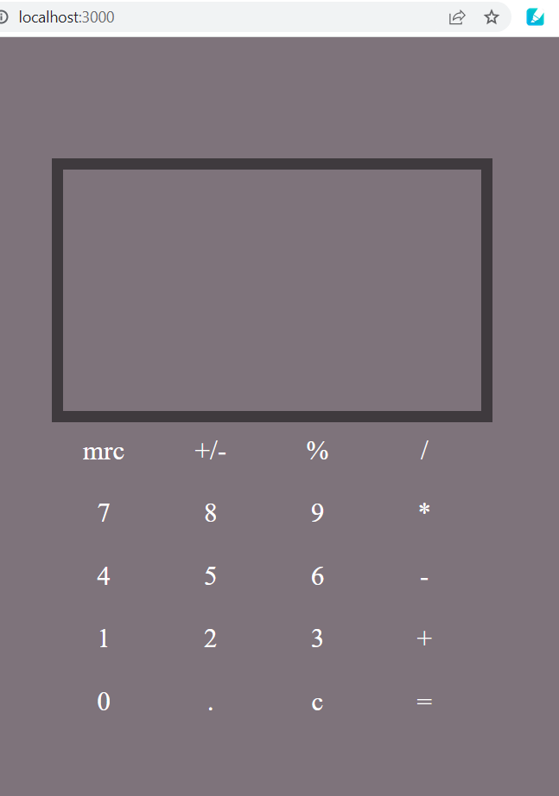

**Practical : 8**

**Aim : Write a program to read data from a text file and write in to another text file using streams.**

**Code :**

var fs = require("fs");

var myReadStream = fs.createReadStream('ab.txt',"UTF8");

myReadStream.on("data", function (chunk)

{

console.log("New chunk has been accepted by the program");

console.log(chunk);

});

var myWriteStream = fs.createWriteStream('writeInMe.txt', "UTF8");

myReadStream.on("data", function (chunk)

{

console.log("New chunk has been accepted by the program");

myWriteStream.write(chunk);

console.log("Chunk written to the new text file");

});

**Output :**

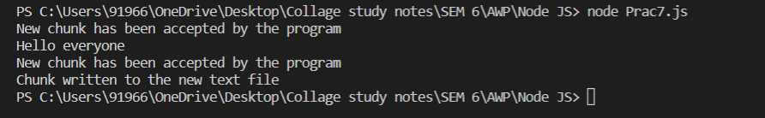

**Practical : 9**

**Aim : Create a Node Js program to demonstrate session management.**

**Code :**

const express = require('express');

const session = require('express-session');

const app = express();

app.use(session ({secret:'secret.key',resave:true,

saveUninitialized : true

}));

app.get('/',(req,res)=>

{

req.session.name="student";

res.send("session start");

});

app.get('session',(req,res)=>{

var name = req.session.name;

res,send(name);

});

app.listen(3000,(err)=>

{

if (err) throw err;

console.log("server started")

});

**Output :**

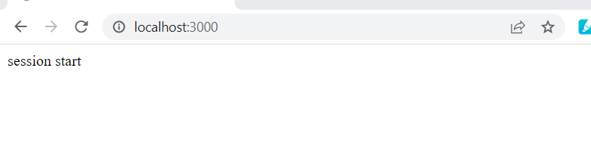

**Practical : 10**

**Aim : Create a database in MongoDB and enter the documents in collections.**

**Code :**

1. To create a database: ➢

* use database_name

1. View all database: ➢

* show dbs

1. View current Database:

* db

1. To create collection and insert documents:

* db.collection_name.insert({ _id:1, name:”Dhiraj”, branch:”IT”, sem: 6})

1. To list all collections in database: ➢

* show collections

1. To list items of collections:

* db.collection_name.find( )

1. To list all collections in database (Prettified):

* db.collection_name.find().pretty()

**Output :**

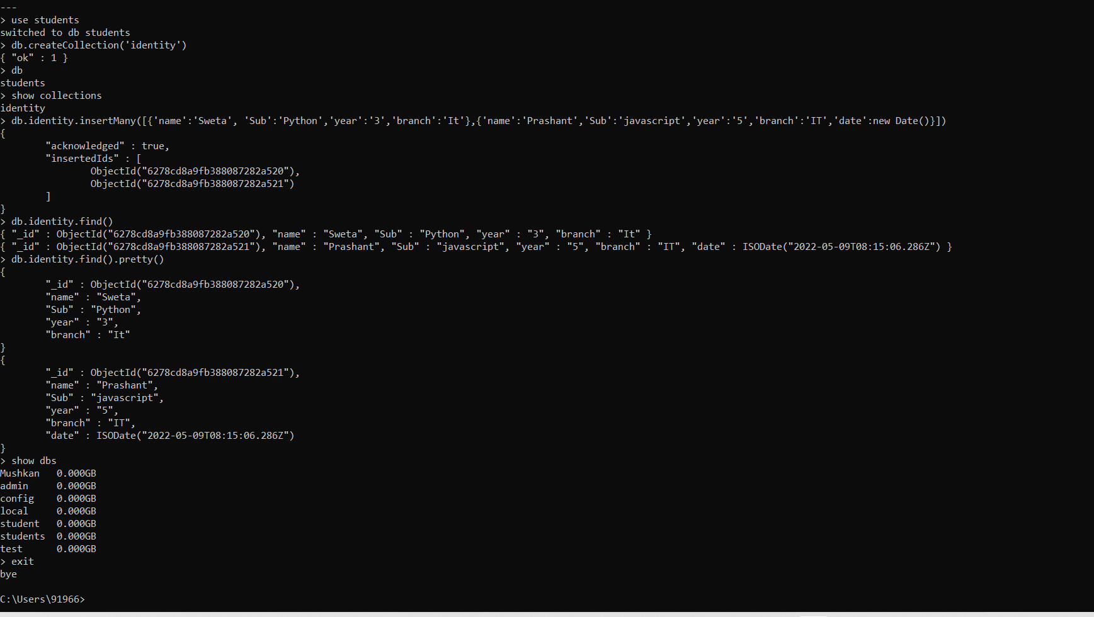

**Practical :11**

**Aim : Write a program to connect NodeJS with MongoDB and display the data from the**

**database.**

**Code :**

const mngs = require('mongoose');

mngs.connect("mongodb://localhost:27017/IT",{useNewUrlParser:true, useUnifiedTopology: true}).then (()=> {

console.log("connection successfull and database created");

})

.catch(() => {console.log(err);});

const s1 = new mngs.Schema({enroll:Number,

name:String,location:{type:String,default:"Vapi"},pincode:Number});

const group = new mngs.model('Student_details',s1);

const createDoc = async() =>

{

const p1 = new group({enroll:01,name:'Siya',pincode:361458});

const p2 = new group({enroll:02,name:'Riya',pincode:200031});

const p3 = new group({enroll:03,name:'Jiya',pincode:396210});

const p4 = new group({enroll:04,name:'Diya',pincode:789526});

const finish = await group.insertMany([p1,p2,p3,p4]);

console.log("data stored");

};

createDoc();

const printData = async () => {

const print = await group.find();

console.log(print);

};

printData();

**Output :**

